**Light as Logic: Exploring Photonic Qubits for Quantum Computing**

Abstract:

Quantum computing leverages qubits, which can exist in superposition and entanglement, enabling solutions beyond classical capabilities. This paper explores the potential of electromagnetic (EM) wave-based qubits, specifically in photonic quantum computing, as a promising medium for quantum information. We investigate how EM wave properties (amplitude, phase, and polarization) can represent qubit states, simulate core quantum operations (superposition, entanglement, teleportation, quantum key distribution) using the Qiskit framework, and analyze the effects of noise. Through detailed simulations and visualizations, including histograms, Bloch spheres, and wavefunction city plots, we demonstrate that light's properties closely mirror qubit systems. While challenges remain for general-purpose quantum computing, photonic qubits offer immense promise, particularly in secure communication and quantum networking, providing a viable and scalable medium for future quantum protocols.

# 1. Introduction

Quantum computing is fundamentally changing the landscape of computation, enabling solutions to problems that are infeasible for classical computers. At its core lies the qubit, a quantum unit of information that, unlike classical bits, can exist in superposition and have measurable phase relationships. While superconducting circuits and trapped ions are popular implementations, photons—the fundamental particles of light—offer unique advantages such as low decoherence, high-speed transmission, and natural mobility, making them compelling candidates for qubit implementation.

This paper investigates the feasibility and design of photonic qubits based on electromagnetic wave properties and explores how they may contribute to scalable, high-speed quantum systems. Our central hypothesis is that it is possible to represent and manipulate quantum information using photon polarization as qubits, simulating core quantum operations such as superposition, entanglement, and quantum teleportation. By visualizing the wavefunction and Bloch sphere of photon-based qubits in simulation, we can demonstrate that light is a viable and scalable medium for future quantum communication and computing protocols, including quantum teleportation and BB84.

Specifically, this research aims to:

* Map electromagnetic wave properties (amplitude, phase, polarization) to qubit states.
* Simulate fundamental quantum operations (superposition, entanglement,

quantum te eportation, quantum key distribution) using the Qiskit framework.

* Analyze the impact of decoherence (noise) on photonic qubit states.
* Visualize quantum states and measurement outcomes using histograms, Bloch spheres, and wavefunction "city plots."

# 2. Theoretical Framework: Photonic Qubits

A classical bit is binary (either 0 or 1). A quantum bit (qubit), however, is described as a linear combination:

$$∣ψ⟩=α∣0⟩+β∣1⟩$$

$where ∣α∣2+∣β∣2=1$ and $α, β$ are complex numbers encoding amplitude and phase. Elecctromagnetic (EM) waves exhibit similar descriptors, making them a natural fit for qubit implementation.

## 2 .1 Encoding Qubits with Light

Photonic quantum computing primarily uses photons to encode and process quantum information. The two main methods of encoding are:

## 2 .1.1 Polarization Encoding

This is the most common and intuitive mapping for photon qubits:

* $0=$ Horizontally polarized photon $(H)$
* $1=$ Vertically polarized photon $(V)$
* **Superpositions:**  Diagonal $(+=21 ( H+V)),$ circular, and elliptical polarizations c orrespond to various superpositions of 0 and 1.

## 2 .1.2 Path Encoding

I n this method, a single photon travels along two distinct paths simultaneously, representing the 0 and 1 states.

### 2.2 Optical Components as Quantum Gates

Optical components can directly implement quantum logic gates:

* **Wave Plates:** These devices rotate the polarization of light. For example, a half-wave plate at 45 acts as an X gate (flips $H↔V),$ and a quarter-wave plate

introduces a phase shift (e.g., transforming H to circular polarization, corresponding to adding a phase of $ϕ=π/2).$

* **Beam Splitters:** A 50/50 beam splitter acts as a Hadamard gate in path encoding, creating a superposition of path states: $0→(1/2) (0+1).$ They are

al o crucia for creating entanglement in polarization encoding.

* **Phase Shifters:**  Directly modify the quantum phase of a photon.
* **Polarizers:**  Act as measurement devices, collapsing the photon's polarization state to a specific basis (e.g., horizontal or vertical).
* **Interferometers:**  Devices like Mach-Zehnder Interferometers can mimic CNOT and phase gates by adjusting phase in one arm, enabling complex logic operations and interference patterns.

# 3. Advantages of Using Photons as Qubits

Photons offer unique advantages that make them compelling candidates for quantum information processing:

1. **Low Decoherence:**  Photons interact very weakly with their environment, making them highly resistant to decoherence. This allows quantum states encoded in light to remain stable over long distances and periods, ideal for quantum communication.
2. **Room-Temperature Operation:**  Unlike many matter-based qubit systems (e.g., superconducting qubits) that require ultra-cold environments, photonic systems can function at room temperature, making them more accessible and scalable.
3. **High-Speed Transmission:**  As the fastest known information carriers, photons are naturally suited for high-speed quantum communication and real-time distributed quantum computing.
4. **Long-Distance Quantum Communication:**  Photons can travel through optical fibers or free space over large distances with minimal loss, enabling protocols like quantum teleportation, entanglement distribution, and quantum key distribution (QKD).
5. **Easier Integration with Classical Optics:**  Photonic qubits can be manipulated using well-understood and commercially available classical optics technologies, allowing smoother integration into hybrid quantum-classical systems.
6. **Scalability and Miniaturization:**  Advances in photonic integrated circuits (PICs) are making it possible to scale up quantum photonic systems using chips that manipulate light at the nanoscale, paving the way for compact and scalable quantum processors.
7. **Compatibility with Existing Infrastructure:**  Because photons can be transmitted via standard telecom fiber networks, photonic qubits are more compatible with today's communication infrastructure, accelerating adoption in real-world applications.

# 4. Simulation Methodology

Our re earch uti izes the Qiskit quantum computing framework in Python to simulate various quantum phenomena relevant to photonic qubits.

**Tools Used:**

* **Python:**  The primary programming language for scripting the simulations.
* **Qiskit:**  IBM's open-source quantum computing framework for building and simulating quantum circuits. We specifically use qiskit_aer for high-performance local simulators.
* **Matplotlib:**  Python library for generating high-quality plots and visualizations (histograms, Bloch spheres, wavefunction city plots).
* **Google Colab:**  The cloud-based environment used for running the simulations.

General Approach:

For each simulation, a quantum circuit is constructed using Qiskit. Depending on the goal, either a qasm_simulator (for measurement outcomes and histograms) or a statevector simulator (for direct state analysis and Bloch sphere/wavefunction plots) from qiskit_aer is used. For statevector simulations involving measurements, a copy of the circuit with final measurements removed is used to allow get_statevector to function. Partial trace is employed to isolate the state of specific qubits from multi-qubit systems, and various visualization functions are used to interpret the results.

**Note:**  Since Qiskit does not natively simulate the physical optics (like beam splitters or polarizers), we abstract the photon qubit behavior via quantum gates acting on polarization-encoded qubits.

# 5. Simulation Results and Discussion

We simulated several core quantum phenomena to demonstrate the viability of light as qubits and to verify the principles of quantum information processing.

### 5.1 Superposition Simulation

A fundamental quantum property is superposition, where a qubit can exist in a combination of 0 and 1 simultaneously. We simulate a single qubit placed in s uperposition using a Hadamard gate and then measure it. This process mimics a p hoton that, after passing through a 50/50 beam splitter or being prepared in a diagonal polarization state, has an equal probability of being detected in either of two o rthogonal states.

**Quantum Operation:**  Applying a Hadamard (H) gate to a qubit initially in $0$ creates t he state: $ψ=(1/2 )(0+1).$

**L ight-Wave Analogy:** T his is directly comparable to a photon encountering a 50/50 beam plitter and having equal probability of being transmitted or reflected, or a diagonally polarized photon being measured in a horizontal/vertical basis.

Result:

The measurement histogram shows an approximately 50/50 split between 0 and 1 outcomes.

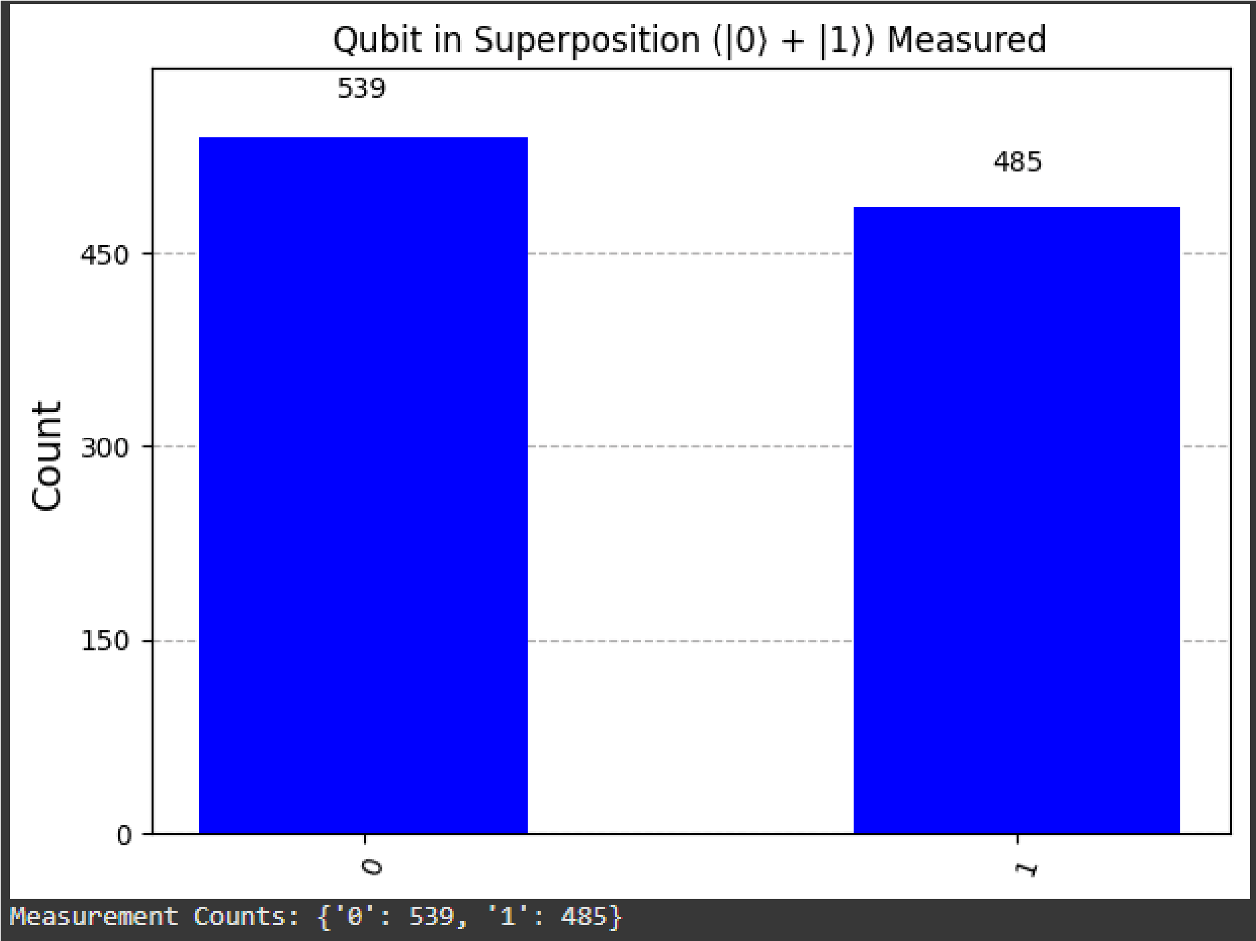

Figure 1: Measurement outcomes for a qubit in superposition after a Hadamard gate. The c ounts are approximately equal for 0 and 1, demonstrating the probabilistic nature of q uantum measurement.

**Interpretation:**  This confirms that a single photon's polarization or path state behaves like a quantum qubit in superposition, aligning with the theoretical mapping. The simulation proves that qubits in superposition can be modeled with light wave c oncepts and that photon behavior can be simulated without quantum hardware.

### 5.2 Entanglement Simulation: Bell State

Entanglement is a profound phenomenon where two or more qubits are linked such that measuring one instantly determines the state of the others, regardless of their p hysical separation. We simulate entanglement through the creation of a Bell state, specifically

$∣Φ+⟩=(1/√2)​(∣00⟩+∣11⟩),$ using Qiskit. This state implies that both photons are a lways polarized the same way—either both horizontal (H) or both vertical (V). +

**Quantum Operation:** A Bell state is typically created by applying a Hadamard gate to t he first qubit, followed by a CNOT gate with the first qubit as control and the second a s target.

**M apping to Light:**  This corresponds to entangled photon pairs generated, for example, via Spontaneous Parametric Down-Conversion (SPDC), where two photons are created with linked polarizations.

Result:

The measurement histogram confirms the result, showing almost exclusively $00 and 11$ outcomes, with negligible counts for 

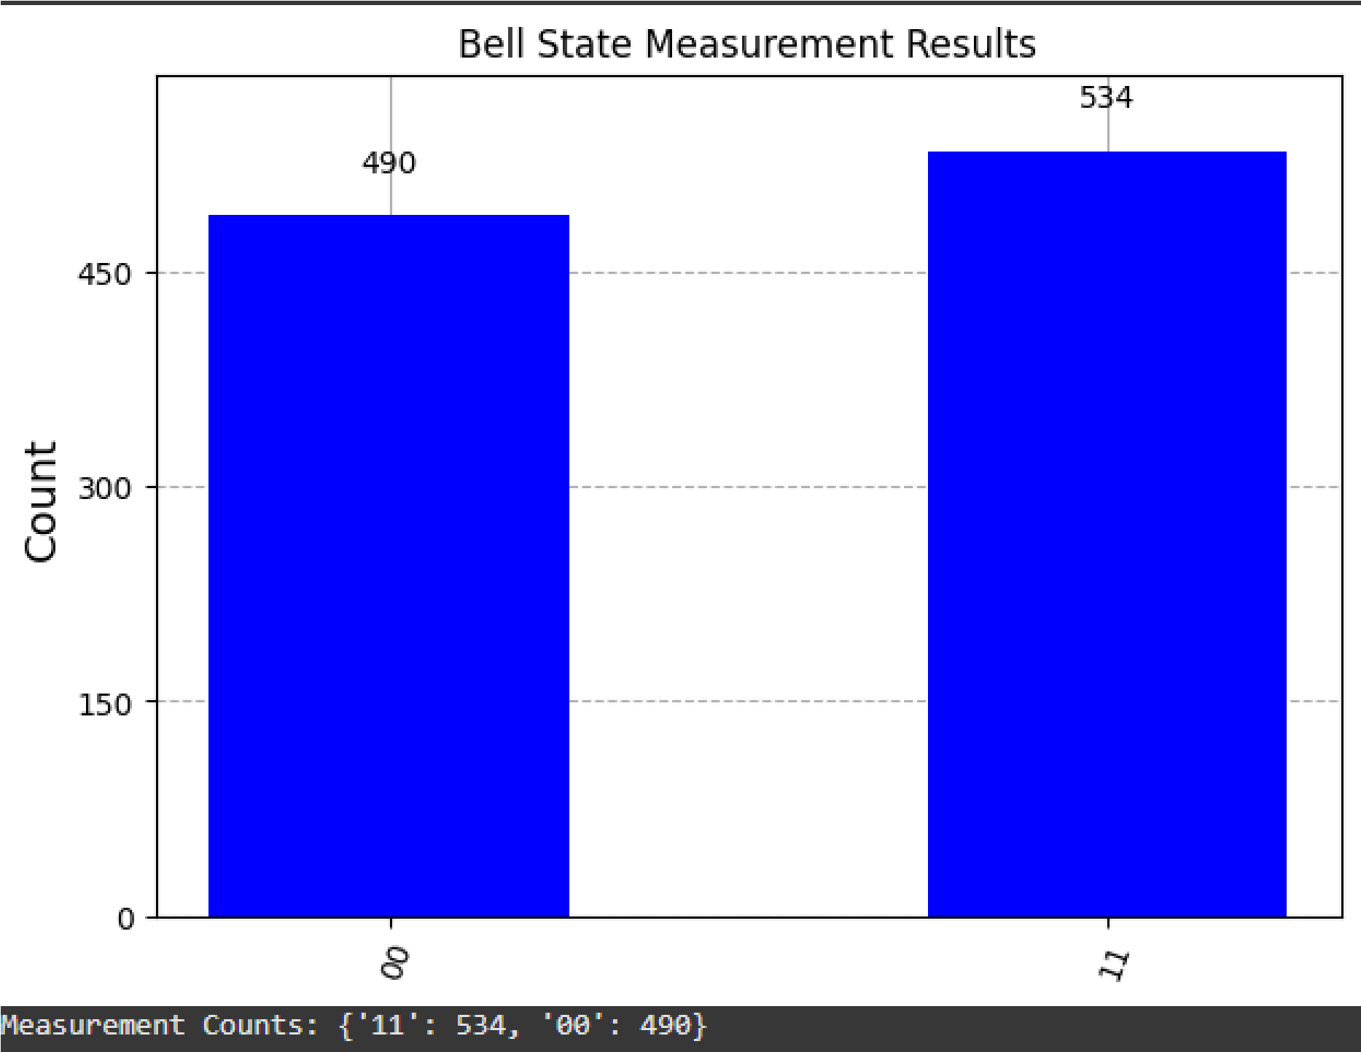

Figure 2: Measurement outcomes for a Bell state. The high counts for 00 and 11

demonstrate perfect entanglement, where both qubits are always measured in the same state.

**Interpretation:**  This simulation accurately reflects experimental photon entanglement behavior, proving that photonic qubits behave according to quantum mechanical predictions and supporting the use of polarization of light for qubit encoding.

## 5 .3 GHZ State Simulation (Tripartite Entanglement)

A GHZ (Greenberger–Horne–Zeilinger) state is a special 3-qubit entangled state where all qubits behave as one, even when separated by large distances. For example,

$∣GHZ⟩=(2​√1)​(∣000⟩+∣111⟩).$ This state implies that if you measure one qubit, you instantly k now the value of the others. This is a quantum-only behavior, impossible in classical s ystems.

**Quantum Operation:** T o create a GHZ state, a Hadamard gate is applied to the first q ubit, followed by two CNOT gates to entangle the first qubit with the second and third qubits.

Result:

The histogram primarily shows two states: $000 and 111$, confirming that the qubits are entangled and not behaving independently.

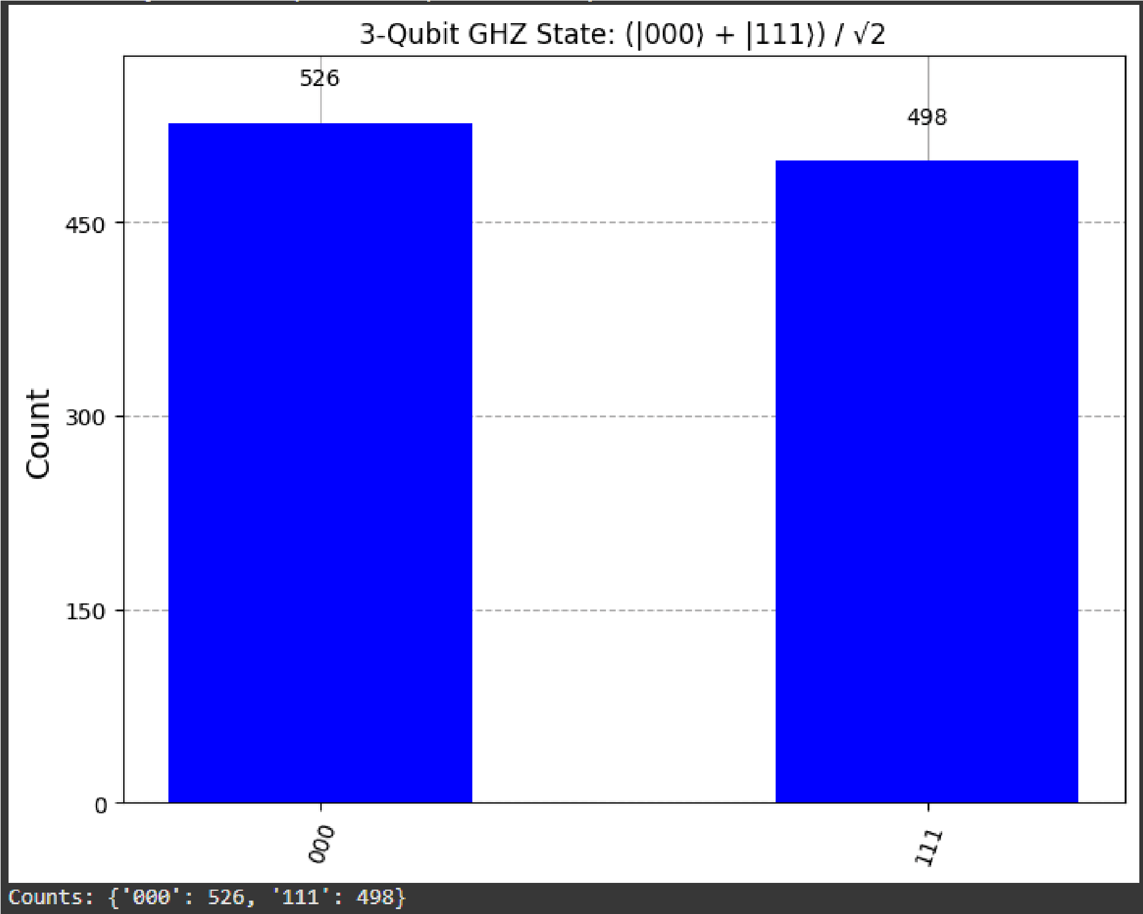

Figure 3: Measurement outcomes for a 3-qubit GHZ state. The dominant counts for 000 and 111 confirm tripartite entanglement.

**Interpretation:** T his experiment supports the core idea that quantum entanglement, such as in a GHZ state, can potentially be implemented using photonic systems, where coherence and synchronization can mimic multi-qubit behavior, crucial for multi-party quantum communication.

## 5 .4 Quantum Teleportation Simulation

Quantum teleportation allows the transfer of an unknown quantum state from one q ubit (Alice's) to another (Bob's) without physically moving the qubit itself, utilizing entanglement and classical communication.

**Protocol Summary:**

1. **Prepare Initial State:** Q ubit 0 (Alice's qubit) is prepared in the state to teleport ( e.g., +).
2. **Create Bell Pair:**  An entangled Bell pair is created between Qubit 1 (Alice's auxiliary qubit) and Qubit 2 (Bob's qubit).
3. **Alice's Operations:**  Alice performs CNOT and Hadamard gates on Qubit 0 and

Qubit 1.

1. **Alice's Measurements:**  Alice measures Qubit 0 and Qubit 1, obtaining two classical bits.
2. **Classical Communication:**  Alice sends these classical bits to Bob.
3. **Bob's Corrections:**  Bob applies conditional X and Z gates to Qubit 2 based on Alice's classical bits.
4. **Verification:**  The state of Qubit 2 is then verified to match Qubit 0's initial state.

Result:

We visualize the initial state of Qubit 0 and the final state of Qubit 2 on the Bloch sphere.

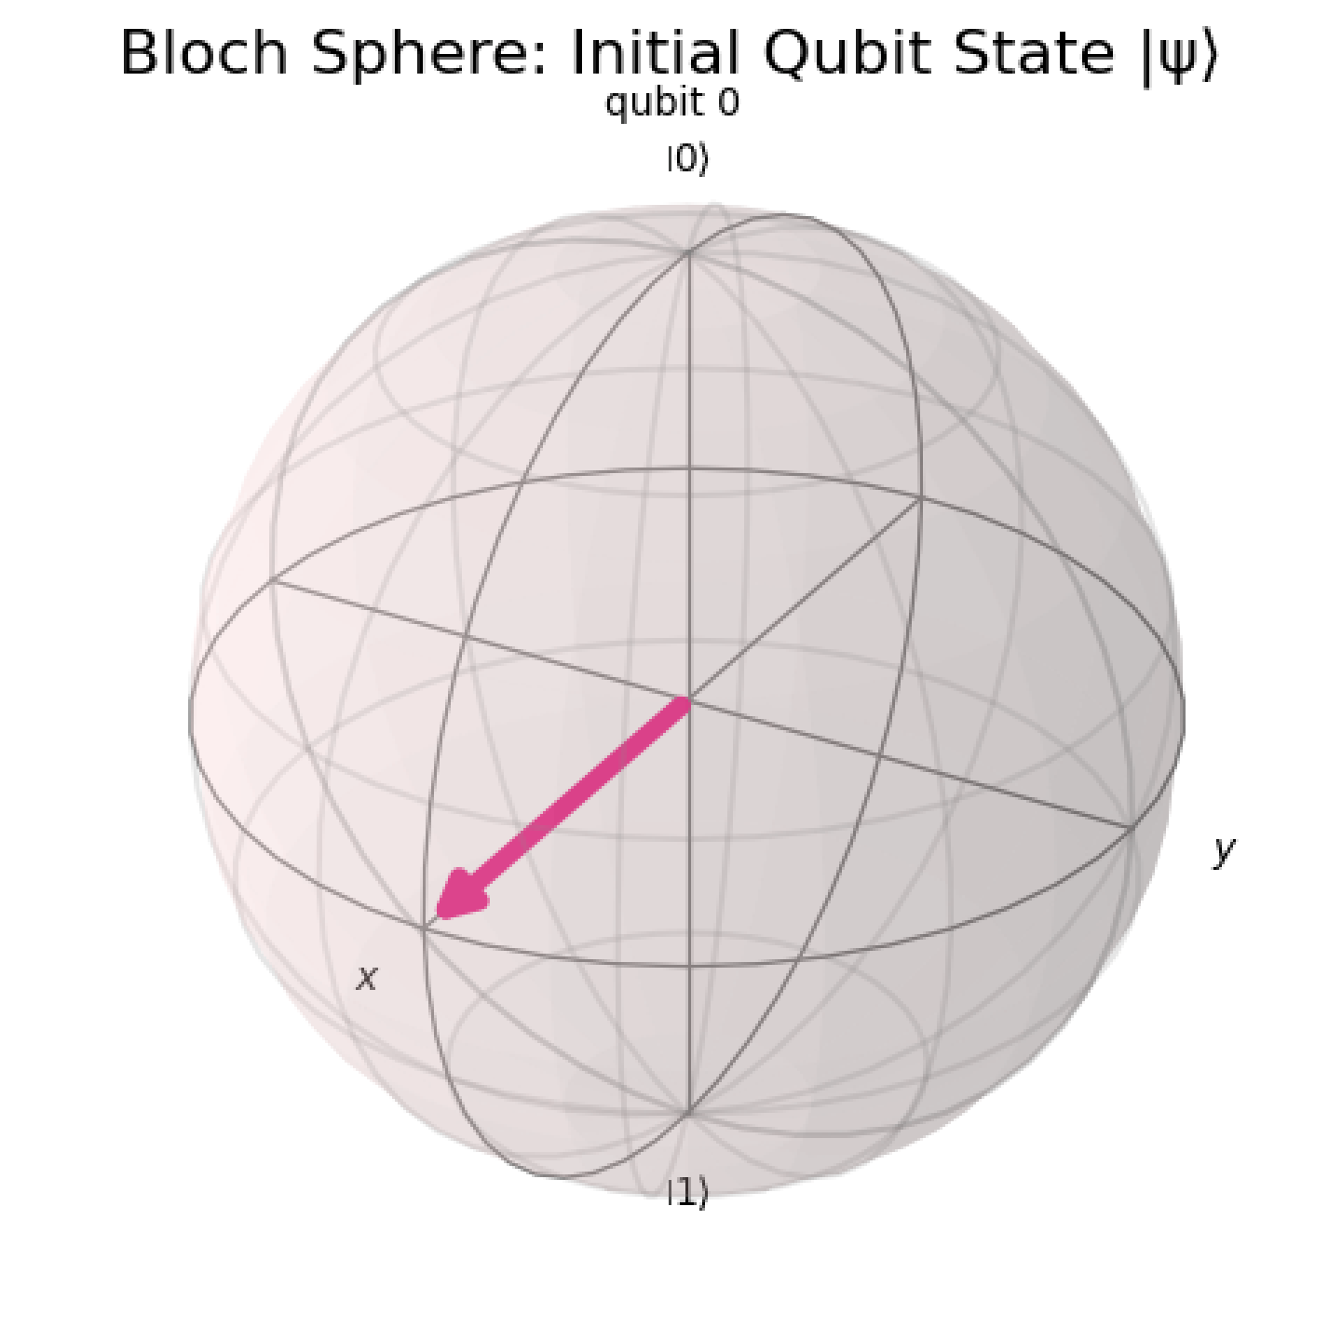

Figure 4: Bloch Sphere representation of the initial qubit state (+), pointing towards the +X axis.

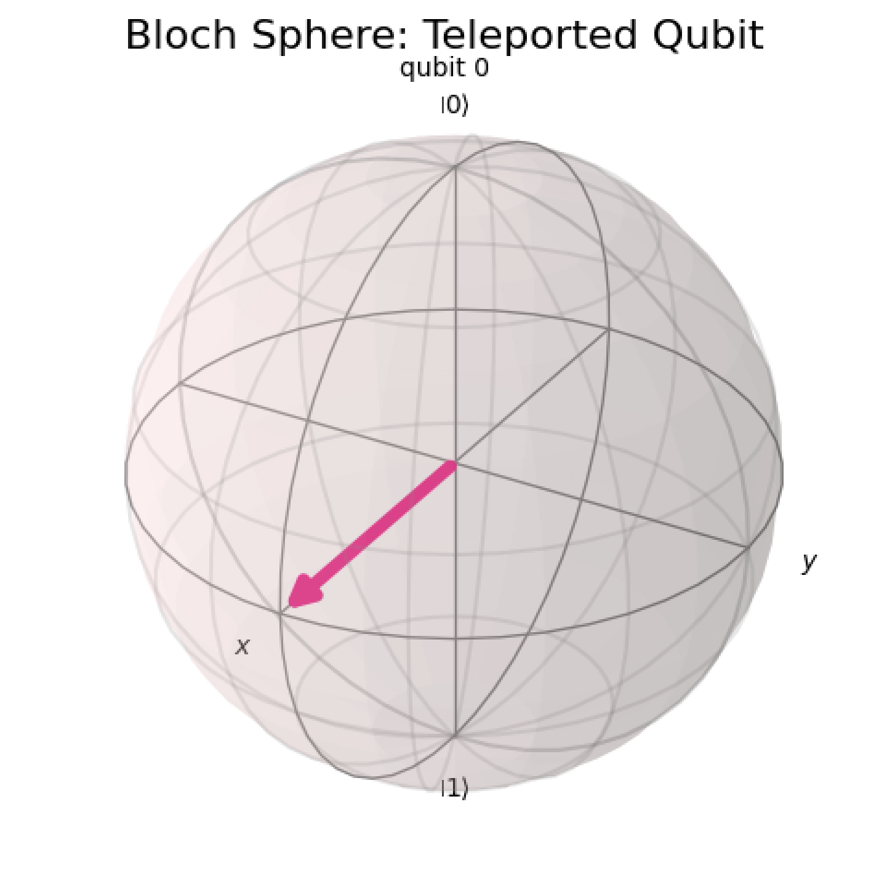

Figure 5: Bloch Sphere representation of the teleported qubit state (Qubit 2) after the protocol, also pointing towards the +X axis.

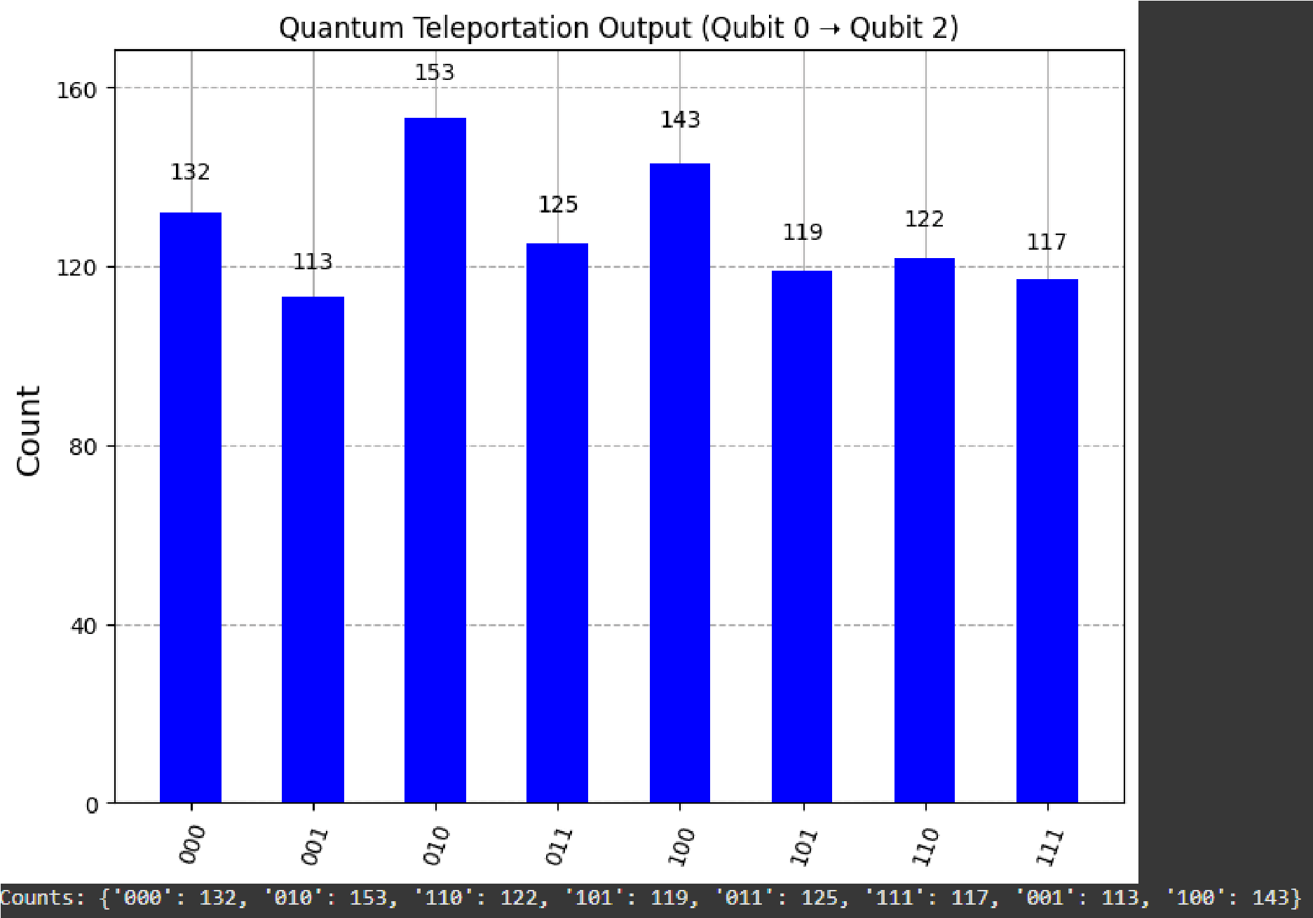

*Figure 6: Overall measurement outcomes for the 3-qubit system after the quantum teleportation circuit. This histogram shows the distribution of all possible joint states, which when correctly interpreted with the protocol, leads to the teleported state on Qubit*

**Interpretation:**  The Bloch sphere of the teleported Qubit 2 perfectly matches the initial state of Qubit 0, confirming successful quantum teleportation. This protocol is crucial for long-distance quantum communication with photons, demonstrating that quantum states can be transferred using entanglement and classical communication, even if the qubit itself is not transmitted.

### 5.5 Quantum Key Distribution (BB84) Simulation

BB84 is the first and most famous Quantum Key Distribution (QKD) protocol, introduced by Charles Bennett and Gilles Brassard in 1984. It uses quantum properties of photons to securely exchange a secret cryptographic key between two parties (Alice and Bob), such that any eavesdropper (Eve) will be detected due to quantum measurement disturbance.

My Approach: Light as Qubits:

In this research, we simulate BB84 using photon-based qubits, where:

$$∣0⟩∣1⟩∣+⟩∣-⟩​=∣H⟩ (horizontal)$$

$$∣1⟩=∣V⟩ (vertical)$$

$$|+⟩ = (1/√2)(|0⟩ + |1⟩)$$

$$∣-⟩=(1/√2​​)(∣0⟩-∣1⟩)​$$

These four states correspond to two polarization bases: Rectilinear ($Z-basis: 0, 1$) and Diagonal ($X-basis: +, -$).

**Protocol Steps Simulated:**

1. A lice randomly chooses bits and bases, then encodes each bit in a corresponding polarization.
2. A lice sends the photons (qubits) to Bob.

3 . Bob randomly chooses a basis for each photon to measure.

1. T hey compare the basis choices publicly (not the bit values).
2. Matching basis measurements are kept to form a shared secret key.
3. Check for eavesdropping by comparing a subset of the key. If an eavesdropper is detected, the key is discarded.

R esult (No Eve):

When no eavesdropper is present, Alice and Bob successfully establish a shared secret key.

The Quantum Bit Error Rate (QBER) is 0%, indicating perfect key agreement.

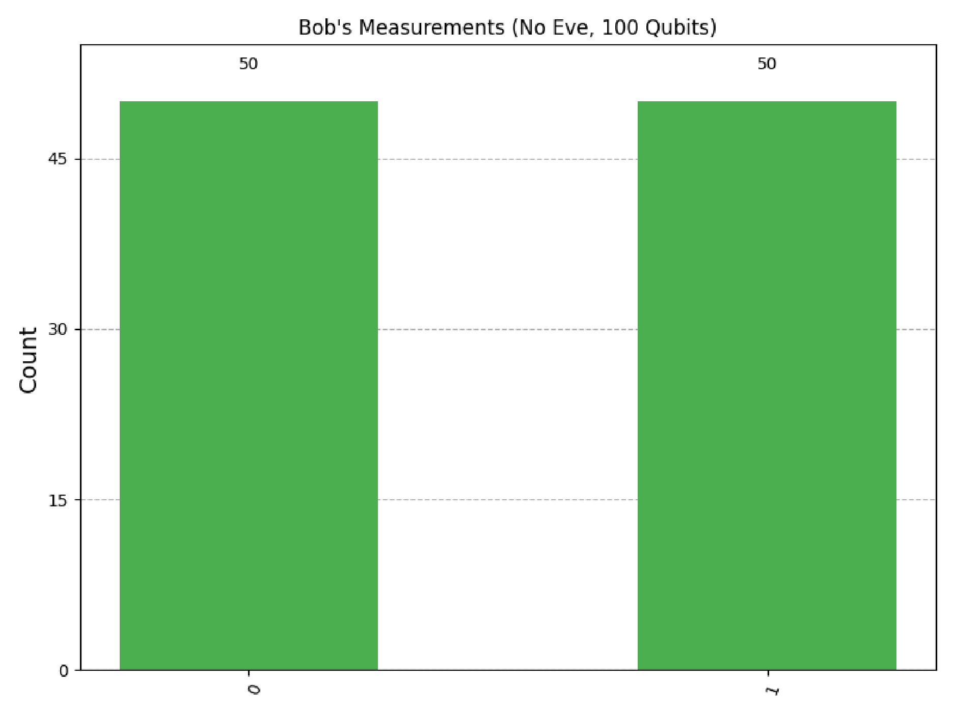

Figure 7: Bob's measurement outcomes without Eve. The 50/50 distribution is expected for random basis choices, and the QBER is 0%.

Result (With Eve):

When Eve is present, she intercepts each qubit, measures it in a randomly chosen basis, and then re-encodes it based on her measurement before sending it to Bob. This act of measurement by Eve disturbs the quantum state.

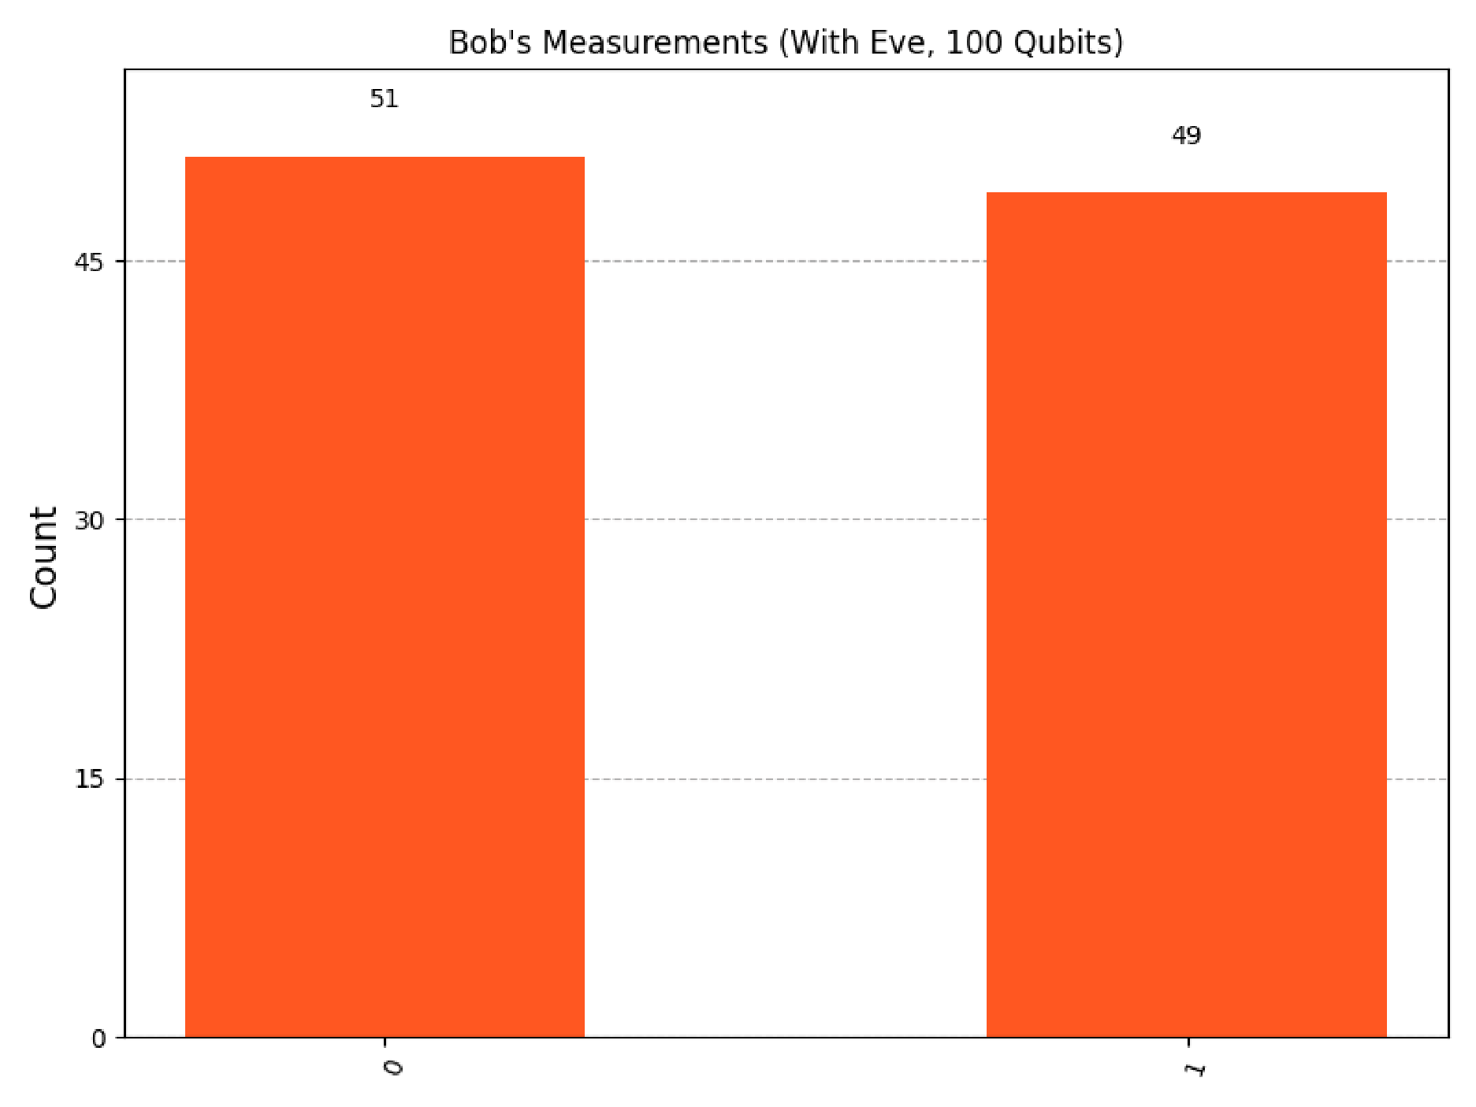

Figure 8: Bob's measurement outcomes with Eve. The increased spread and non-zero QBER (e.g., ~25%) indicate Eve's presence.

**Interpretation:**  The significant increase in QBER (e.g., from 0% to ~25%) when Eve is active is the signature of an eavesdropper in BB84. This demonstrates that eavesdropping is detectable due to quantum no-cloning and the collapse of the wavefunction upon measurement. Simulating BB84 with photons as qubits supports the vision that quantum light is not just a medium for data, but for security infrastructure, proving the real-world relevance of photonic quantum computing.

### 5.6 Simulating Decoherence (Noise in Photonic Qubits)

In real-world quantum systems, qubits interact with their environment and lose coherence over time (decoherence). While photonic qubits are less susceptible to certain types of noise during propagation, they still face challenges like photon scattering, phase noise in optical fibers, or beam misalignment. Decoherence causes a loss of quantum information, degrading superposition and entanglement.

**Simulating Noise with Qiskit:**  We used Qiskit's NoiseModel API to mimic depolarizing error (e.g., a 2% chance) on gates like Hadamard, Pauli-X, and CNOT, which can represent photon scattering or polarization drift.

Result:

The histogram for the GHZ state with depolarizing noise shows deviations from the ideal GHZ state, with small but non-zero counts for states other than $000$ and 

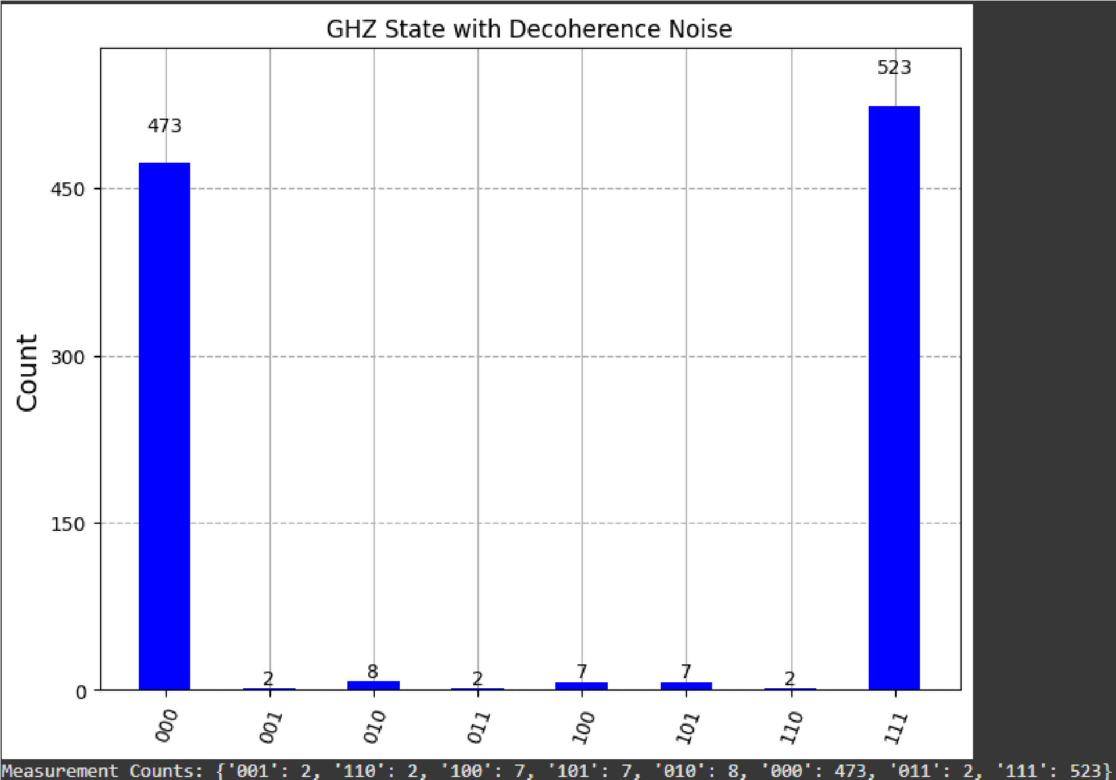

F igure 9: Measurement outcomes for a GHZ state under depolarizing noise. The presence of non-ideal outcomes (e.g., $001, 010$) indicates decoherence.

**I nterpretation:**  This demonstrates how noise degrades the quantum state, leading to l ess probability for the pure GHZ outcomes. This insight is vital for understanding the n eed for error correction and stable optical setups in real-world photonic implementations.

### 5.7 Wavefunction Visualization (City Plots)

The "City Plot" is a powerful visual representation of a quantum state's wavefunction, particularly useful for multi-qubit systems. It displays both the amplitude (height of bars) and the complex phase (color hue) for each possible basis state. For a qubit , $∣ψ⟩=α∣0⟩+β∣1⟩$, the city plot shows α and β as 3D bars.

**Utility:** These plots are invaluable for debugging quantum circuits, understanding complex entanglement patterns, and precisely verifying the state of qubits.

Result:

We visualize the wavefunction of the initial |+ state and the teleported state.

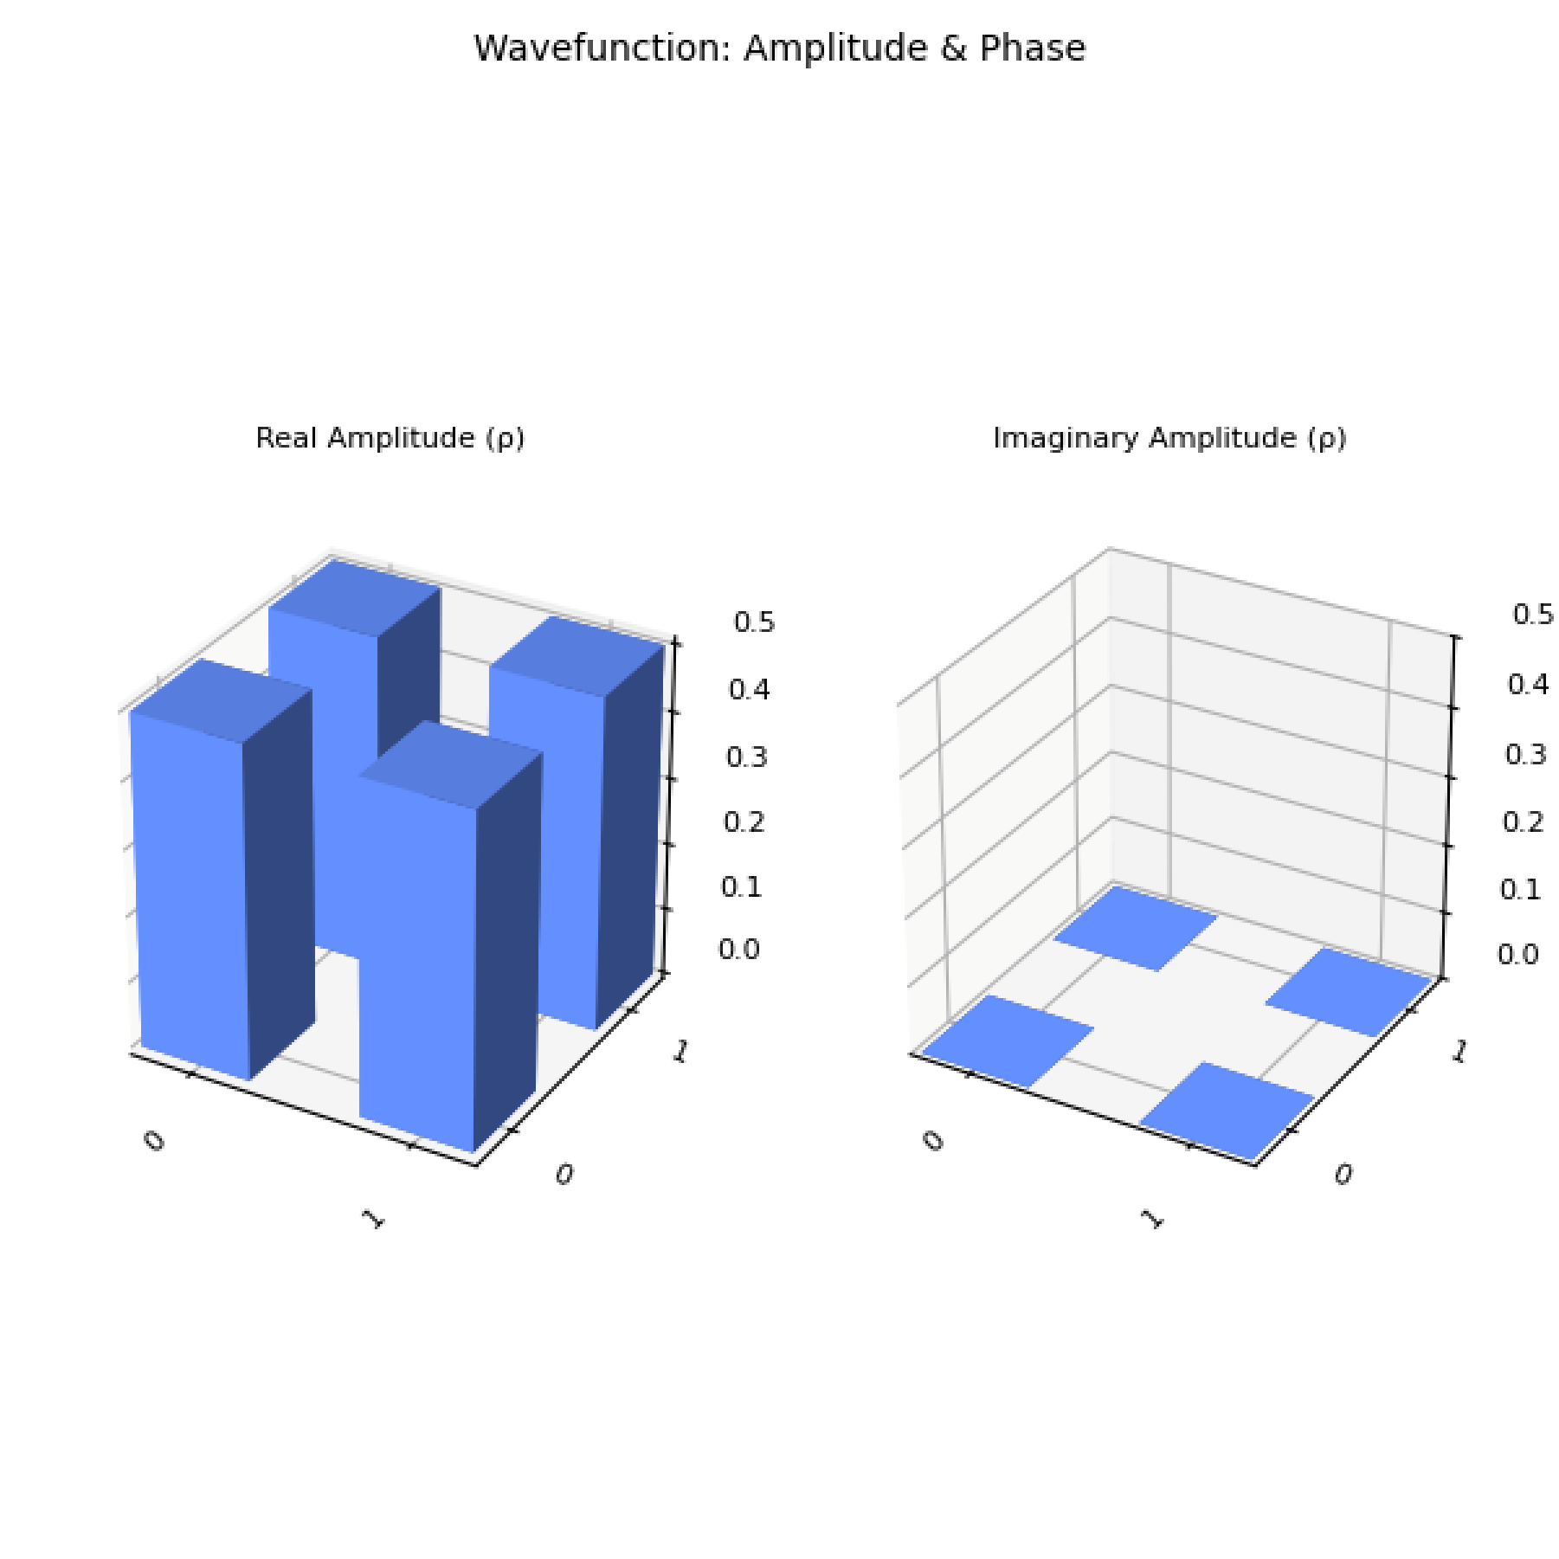

Figure 10: Wavefunction City Plot for the initial + state. It shows equal real amplitudes for $0 and 1$ and no imaginary parts.

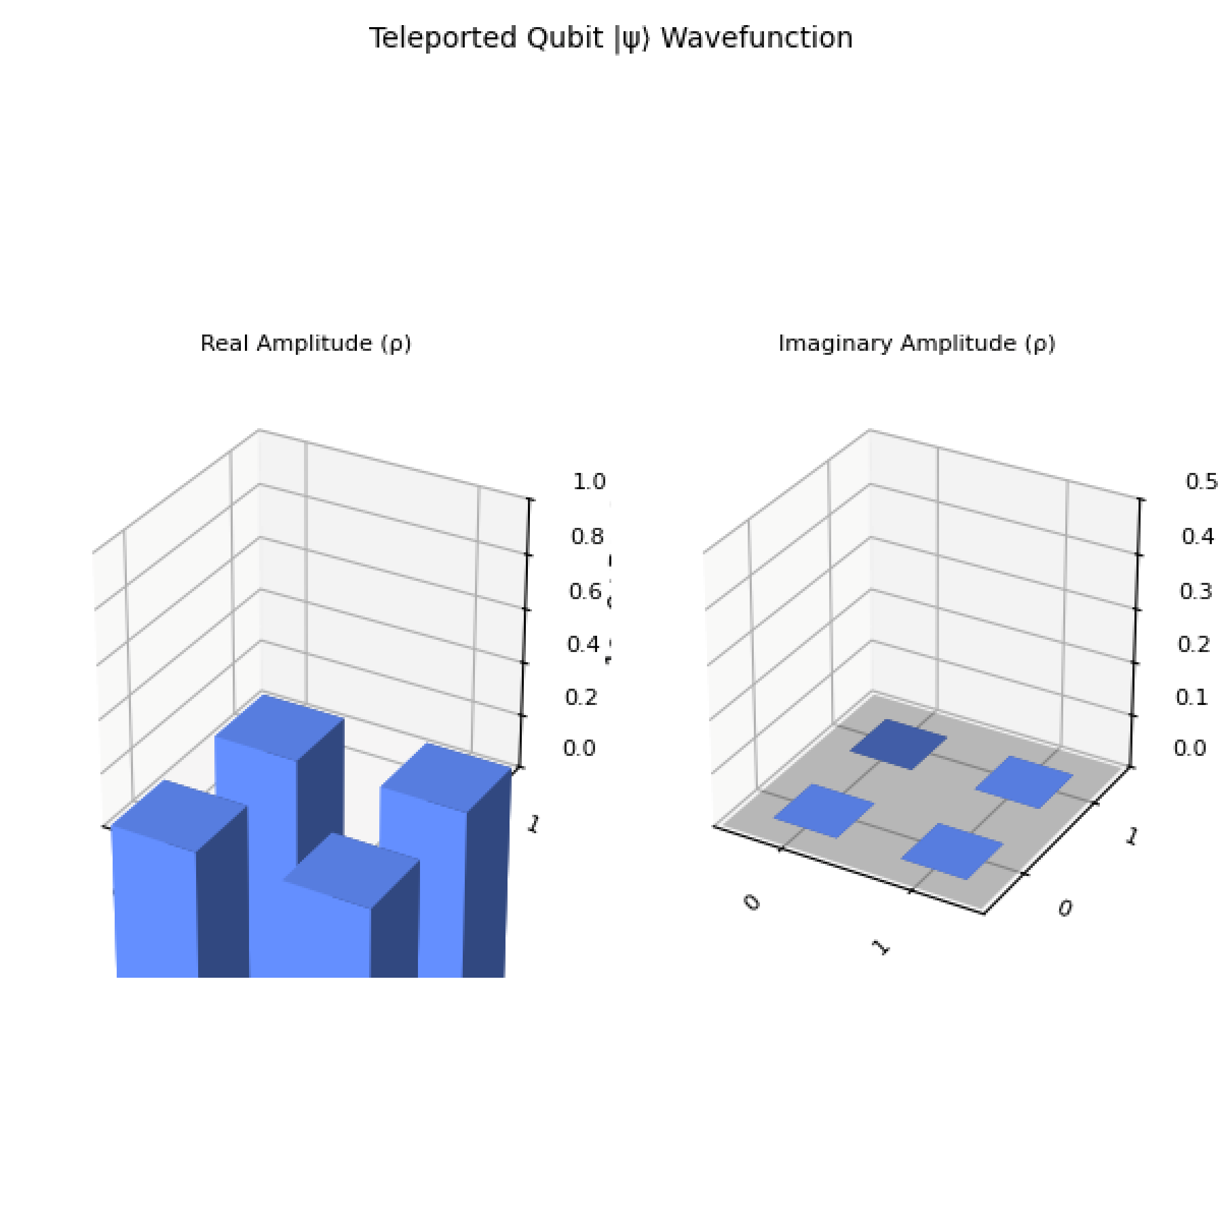

Figure 11: Wavefunction City Plot for the teleported qubit (Qubit 2). It matches the initial state's wavefunction, confirming successful teleportation.

**Interpretation:**  These plots provide a detailed view of the complex amplitudes, allowing for precise verification of state preparation and transformation.

# 6. Real-World Applications of Photonic Qubits

The practical implications of photonic quantum computing are profound, extending beyond theoretical simulations:

1. **Quantum Key Distribution (QKD):**  Polarization-encoded photons are already used in secure communication protocols such as BB84, which leverages quantum superposition and no-cloning principles to enable unbreakable encryption.
2. **Quantum Internet:**  Photonic qubits are ideal for transmitting quantum information over long distances through optical fibers, enabling the quantum internet and entanglement-based communication.
3. **High-Speed Quantum Networking:**  Photons do not require ultra-cold environments and can be manipulated using mature photonics technology, making them excellent candidates for scalable and room-temperature quantum networks.
4. **Hybrid Quantum Systems:**  Photonic qubits can act as interconnects between different quantum systems (e.g., carrying quantum information between superconducting qubit modules or ion-trap processors).
5. **Secure Voting and Authentication:**  Future digital identity systems may leverage entangled photons and polarization encoding to perform secure, verifiable transactions in quantum-resistant authentication systems.

# 7. Future Directions

To overcome current limitations in photonic quantum computing and extend this research, several avenues can be explored:

* **Grover's Algorithm Implementation:**  Implement Grover’s Algorithm under this photonic framework using Qiskit simulations. This would involve demonstrating that polarization-encoded qubits can efficiently perform quantum search operations and visualizing amplitude amplification through Bloch spheres, city plots, and histograms.
* **Physical Implementation Exploration:**  Explore how optical components (like beam splitters and wave plates) might physically implement the necessary Grover operations in future experimental setups.
* **Advanced Gate Mechanisms:**  Investigate using nonlinear crystals or quantum dots to mediate photon interactions for more robust multi-qubit gates.
* **Hybrid Systems:**  Develop hybrid quantum systems combining photons for transmission with other qubit technologies (e.g., superconducting) for logic operations.
* **Improved Components:**  Focus on improving photon source stability and detector sensitivity, which are critical experimental challenges.
* **Phase Manipulation Minimization:**  Research whether fundamental quantum logic gates can be built using polarization-only transformations, minimizing or eliminating the need for complex phase manipulation.
* **Complex Algorithms:**  Simulate more complex quantum algorithms beyond the foundational ones presented here.
* **Advanced Noise Models:**  Explore more sophisticated noise models and error mitigation techniques tailored for photonic systems.

# 8. Conclusion

This paper demonstrates that the properties of electromagnetic waves—especially superposition, phase shift, and polarization—closely mirror qubit properties in quantum computing. Through comprehensive Qiskit simulations of superposition, entanglement (Bell and GHZ states), quantum teleportation, quantum key distribution (BB84), and noise effects, we confirm that EM waves can be a powerful medium for quantum information. Light-based qubits are not just a theory but are simulatable and visualizable, bridging quantum physics with classical optics. While challenges remain for general-purpose quantum computing, photonic qubits offer immense promise, particularly in secure communication and quantum networking, opening doors for further research into scalable and room-temperature photonic quantum logic. The successful simulation and visualization of these protocols provide strong evidence for the feasibility of constructing quantum cryptographic protocols using photon polarization as a qubit encoding method, enabling secure communication and detection of eavesdropping without requiring cryogenic setups or complex quantum hardware.

# References

1. Nielsen & Chuang, Quantum Computation and Quantum Information
2. Xanadu AI - https://www.xanadu.ai
3. IBM Quantum Lab - https://quantum-computing.ibm.com
4. Quirk Quantum Simulator - https://algassert.com/quirk
5. Strawberry Fields - https://strawberryfields.ai

# Code Availability

The full Python code for all simulations and visualizations presented in this paper is available in the following GitHub repository:

https://github.com/Abrar-Muhammad/quantum-computing-project

(Author's Note: Please replace this with your actual GitHub repository URL and consider adding your full name and academic affiliation if applicable for a formal publication.)